Write a program to check Whether Two Strings are Anagrams or not.
#include <stdio.h>
#include <string.h>
#include <ctype.h>

int areAnagrams(char str1[], char str2[]) {
int count[256] = {0};

if (strlen(str1) != strlen(str2))
return 0;

for (int i = 0; str1[i] != '\0'; i++) {
count[tolower(str1[i])]++;
}

for (int i = 0; str2[i] != '\0'; i++) {
count[tolower(str2[i])]--;
}

for (int i = 0; i < 256; i++) {
if (count[i] != 0)
return 0;
}

return 1;
}

int main() {
char str1[100], str2[100];

printf("Enter first string: ");
scanf("%s", str1);

printf("Enter second string: ");
scanf("%s", str2);

if (areAnagrams(str1, str2))
printf("The strings are anagrams.\n");
else
printf("The strings are not anagrams.\n");

return 0;
}

Output:

Write a program to find sum of digits using recursion.

#include <stdio.h>

int sumOfDigits(int n) {
if (n == 0)
return 0;
return (n % 10) + sumOfDigits(n / 10);
}

int main() {
int number;
printf("Enter a number: ");
scanf("%d", &number);

int sum = sumOfDigits(number);
printf("Sum of digits of %d is %d\n", number, sum);

return 0;
}

Output:
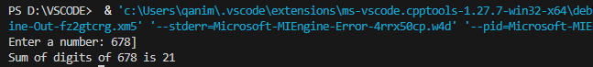

Write a program and a function to swap two numbers using call by reference.
#include <stdio.h>

void swap(int *a, int *b) {
int temp;
temp = *a;
*a = *b;
*b = temp;
}

int main() {
int x, y;

printf("Enter two numbers: ");
scanf("%d %d", &x, &y);

printf("Before swapping: x = %d, y = %d\n", x, y);

swap(&x, &y);

printf("After swapping: x = %d, y = %d\n", x, y);

return 0;
}

Output:
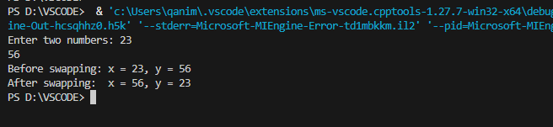

Write a function to sort an array using functions.
#include <stdio.h>

void sortArray(int arr[], int n) {
int i, j, temp;
for (i = 0; i < n ; i++) {
for (j = i+1; j < n ; j++) {
if (arr[i] > arr[j]) {
temp = arr[i];
arr[i] = arr[j];
arr[j] = temp;
}
}
}
}

void printArray(int arr[], int n) {
for (int i = 0; i < n; i++) {
printf("%d ", arr[i]);
}
printf("\n");
}

int main() {
int arr[100], n;

printf("Enter number of elements: ");
scanf("%d", &n);

printf("Enter %d elements:\n", n);
for (int i = 0; i < n; i++) {
scanf("%d", &arr[i]);
}

printf("\nOriginal array: ");
printArray(arr, n);

sortArray(arr, n);

printf("Sorted array: ");
printArray(arr, n);

return 0;
}

Output:
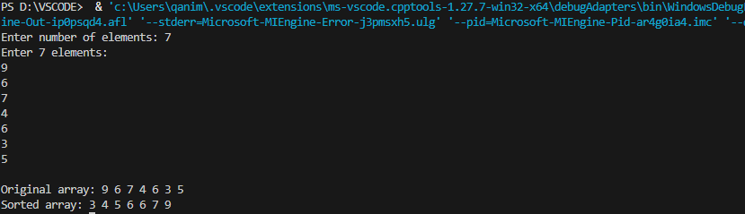

Write a program to define a structure name student with roll number, name, and marks.
Write functions to input and display student details.
#include <stdio.h>

struct Student {
int rollNumber;
char name[50];
float marks;
};

void inputStudent(struct Student *s) {
printf("Enter roll number: ");
scanf("%d", &s->rollNumber);

printf("Enter name: ");
scanf(" %[^\n]s", &s->name);

printf("Enter marks: ");
scanf("%f", &s->marks);
}

void displayStudent(struct Student s) {
printf("\nStudent Details:\n");
printf("Roll Number: %d\n", s.rollNumber);
printf("Name: %s\n", s.name);
printf("Marks: %.2f\n", s.marks);
}

int main() {
struct Student s;

inputStudent(&s);

displayStudent(s);

return 0;
}

Output:
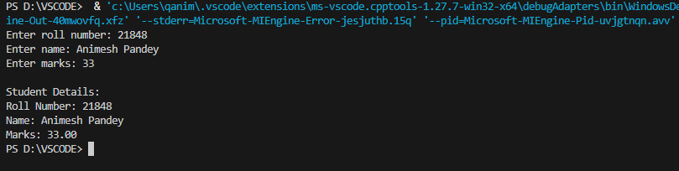

Write a program to create a structure employee (ID, Name, Basic Pay, DA, HRA, Gross Salary).
and write a function to calculate salary and display details.
#include <stdio.h>

struct Employee {
int ID;
char name[50];
float basicPay;
float DA;
float HRA;
float grossSalary;
};

void calculateSalary(struct Employee *e) {
e->DA = 0.1 * e->basicPay;
e->HRA = 0.05 * e->basicPay;
e->grossSalary = e->basicPay + e->DA + e->HRA;

}

void inputEmployee(struct Employee *e) {
printf("Enter Employee ID: ");
scanf("%d", &e->ID);

printf("Enter Employee Name: ");
scanf(" %s", e->name);

printf("Enter Basic Pay: ");
scanf("%f", &e->basicPay);
calculateSalary(e);
}

void displayEmployee(struct Employee e) {
printf("\nEmployee Details:\n");
printf("ID: %d\n", e.ID);
printf("Name: %s\n", e.name);
printf("Basic Pay: %.2f\n", e.basicPay);
printf("DA: %.2f\n", e.DA);
printf("HRA: %.2f\n", e.HRA);
printf("Gross Salary: %.2f\n", e.grossSalary);
}

int main() {
struct Employee e;

inputEmployee(&e);

displayEmployee(e);

return 0;
}

Output:
